Preparing to Implement
Campus Labs Outcomes
- Goal Setting
- Identifying Your Outcomes Team
  - Role Dictionary
- Outcomes Scale
- Template outline worksheets
- Your Campus Outcomes
- Workflow – Building Connections

Goal Setting
What are your campuses goals for using the Outcomes site? How do you hope to leverage your outcomes data?

Implementation Timeline

Role Descriptions and Worksheet
- Who should complete this worksheet?
This worksheet should be completed by the contract signer and/or senior sponsor and supporting team members.

- How will this worksheet be used?
We will use this worksheet to coordinate schedules, meetings, and provide appropriate training and permissions within the toolsets. Please refer to the role dictionary for further descriptions, time commitments/levels of involvement, and examples from other campuses.

- How do I complete this worksheet?
Review all potential roles and complete all those that are relevant. If you have questions, please reach out to your implementation consultant.

- What else should I consider?
- Roles are not exclusive
- An individual may fill multiple roles based on the goals and workflow of your institution and a role may be filled by multiple people. The individual(s) will be responsible for all responsibilities and time commitments in each role. As decisions are made regarding the coordination, timeline, and roles of campus members, consideration of these factors will be essential to a successful implementation.
- This worksheet should continue to be a reference for your campus and updates should be communicated to Campus Labs as necessary based on role changes.

For full details regarding each role and the associated time commitments and responsibilities, please review the following role dictionary.

- Implementation involvement levels
Included in the role details you will find charts for the level of involvement needed from the person identified at each stage of the implementation process. Each level is outlined below.

 | High | Medium | Low | N/A
The identified individual should be prepared to: | Dedicate at least 3 hours a week to training or scheduled calls and action items associated with implementation. | Dedicate around 1-1.5 hour a week to calls and action items. | Updated on progress and may be included in conversations weekly. May be assigned responsibility for an action item if appropriate. | Not involved at this level of implementation
Outcomes Primary Contact

What are the responsibilities of an Outcomes Primary Contact?
This role is responsible for the direction and goals of assessment on campus. They should have a good understanding of the Assessment Cycle and their campus' assessment plan. They should be able to articulate clear expectations to their users as to the quality, quantity, and format that assessment will occur in. Primary Contacts often serve as Site Administrator as well.

On other Campuses, who has been an Outcomes Primary Contact?
Primary Contacts have held titles such as Director of Assessment, Director of Institutional Research, AVP of Academic Affairs, Director of Student Life.

What is the level of involvement and time commitment of a Baseline Primary Contact in orientation and implementation?

Orientation | Technical Implementation | Implementation Training | Launch | Adoption
High | Medium | Medium | High | Low

What is the level of involvement and time commitment of a Baseline Primary Contact after launch?
The Primary Contact will be a contact point on campus for users as well as a contact point for Campus Labs Consultants for regular check-ins around meeting assessment goals, product updates, and product communications.

Outcomes Site Administrator

What are the responsibilities of an Outcomes Site Administrator?
This product specific role is responsible for the maintenance and direction of Outcomes, including contributing to the initial site construction, controlling settings, determining users and permissions, and understanding the detailed functionality of the tool. They will be responsible for implementing the Outcomes platform with an understanding of its relationship to the campus’ assessment strategy. The Site Administrator will be responsible for communicating choices concerning the platform to relevant stakeholders on campus. They are also responsible for training the broader campus audience in product use. We recommend that there are between 1-3 Site Administrators for Outcomes.

On other Campuses, who has been an Outcomes Site Administrator?
Site Administrators have held titles such as Director of Assessment, Director of Institutional Research, AVP of Academic Affairs, Director of Student Life.

What is the level of involvement and time commitment of an Outcomes Site Administrator in orientation and implementation?

Onboarding | Technical Implementation | Implementation Training | Launch | Adoption
High | Medium | High | High | Low

Outcomes Site Administrators will be involved in the Core Data Preparation during on-boarding and technical implementation. They will attend a five-part Implementation Training series introducing settings and functionality of the tool.

What is the level of involvement and time commitment of an Outcomes Site Administrator after launch?
The Site Administrator will be a contact point on campus for users and training as well as a contact point for Campus Labs regarding check-ins, product updates, and product communications.

Outcomes Champion

What are the responsibilities of a Champion?

A Champion is a campus resource who can act in an influential manner on campus. A champion will act as a liaison between the campus audience and the Campus Labs products. The Champion is someone who supports the mission of the campus as well as the solutions proposed in the Campus Labs platforms and is willing to be an advocate on campus. They are a voice from within the campus, an influencer for the adopted solutions, a coach to other users, and a person who will help with successful adoption on campus. The specific responsibilities will vary based on the product, campus environment, and the goals being pursued, but champions are general involved in the launch and adoption of the product on campus

On other Campuses, who has been a Product Champion?
Champions are part of the targeted user base on campus. They have held a variety of positions dependent on the platform and targeted audience.

What is the level of involvement and time commitment of a Baseline Primary Contact in orientation and implementation?

Onboarding | Technical Implementation | Implementation Training | Launch | Adoption
Low | Low | Low | High | Medium

What is the level of involvement and time commitment of a Product Champion after launch ?
A champion will work to know the purpose of the platform and how to showcase its usefulness to the broader audience. A champion will work to build support and engagement with the campus goals among the target audience.

Results Scale
The Results Scale within Outcomes is a universal setting for each academic year and was developed to provide users with a quick view regarding the performance of a given outcome(s). An institution's scale can have anywhere between 2-5 units for their scale and cannot be changed once results have been entered.
Outline your scale
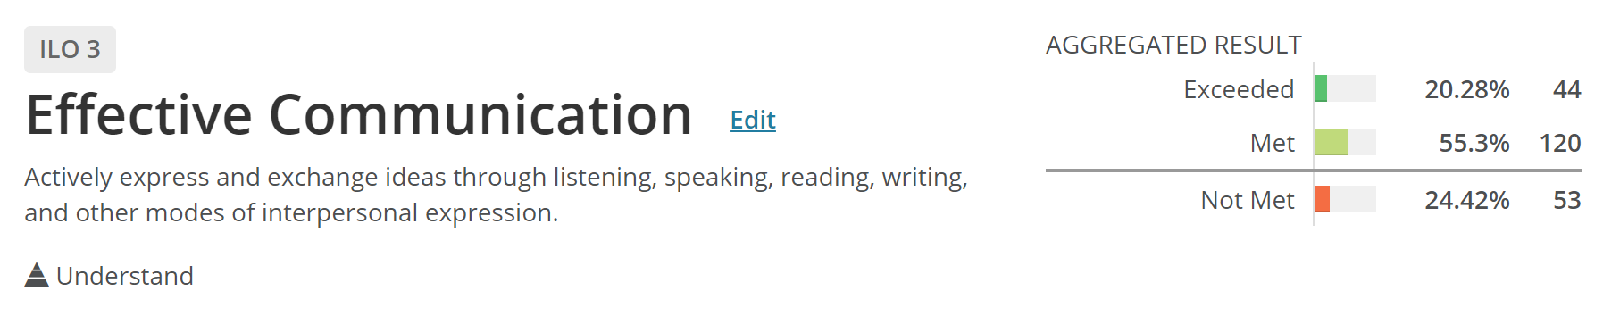
Scale |  | Unit Name
1
2
3
4
5

Scale | Unit
1
2

Example scale labels:
- Exceeded, Met, Partially Met, Not Met
- Beginner, Competent, Advanced, Expert
- No Performance, Improvement Needed, Met Expectations, Exceeded Expectations
- Not Met, Met, Exceeded
- Met, Not Met
Results Scale
Questions to consider:
- Does your campus have a shared scale and common language already in use on campus?

- What would be a potential agreeable scale?

- Who should be included in a conversation on the campus-wide scale?
  - Consider: Anyone who is already involved in aggregate scoring or achievement metrics, General Education representatives, division/department level representation, provost, Institutional Effectiveness and Research., etc.

- What campus factors should be considered in selecting a scale?

Bloom’s Taxonomy Display:

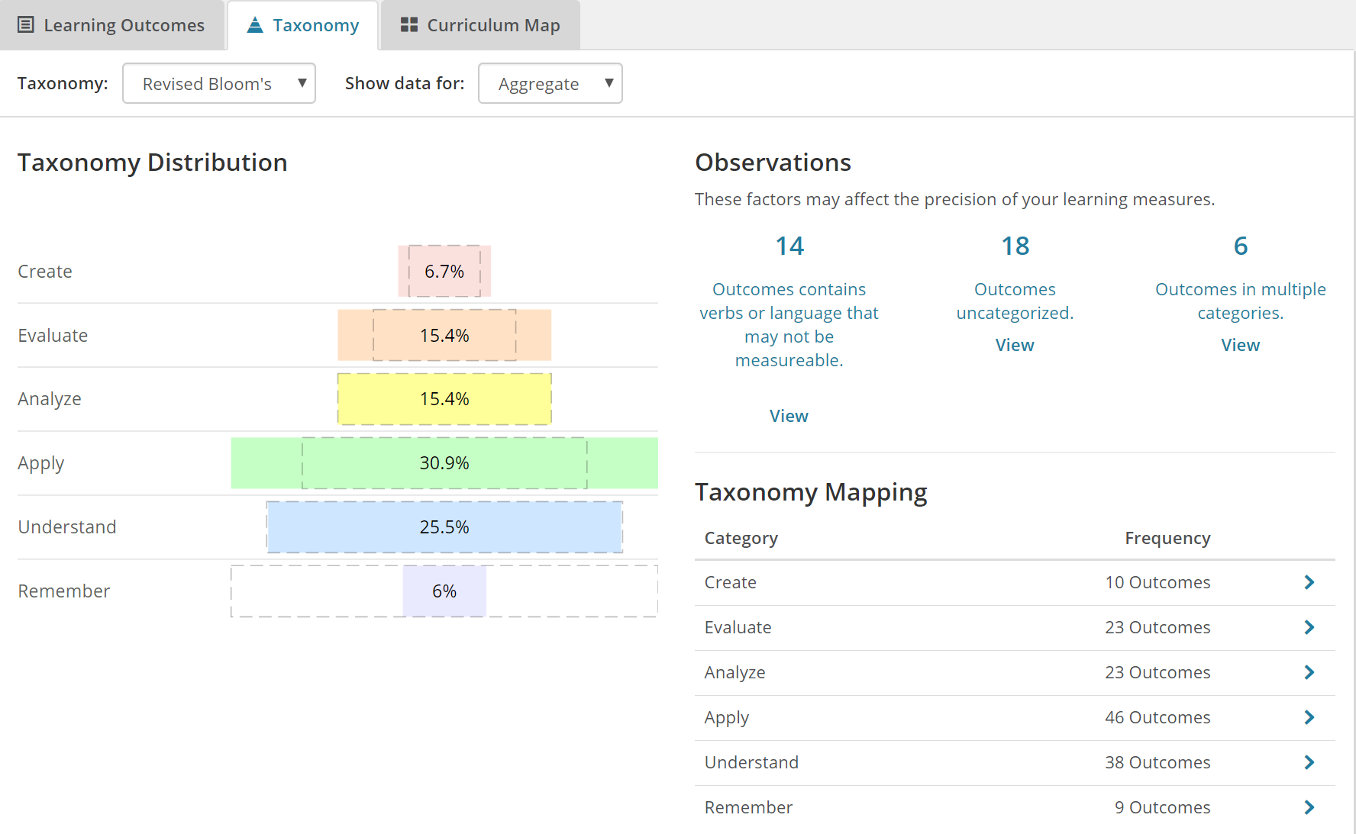

Templates

Outcome Statement Template:
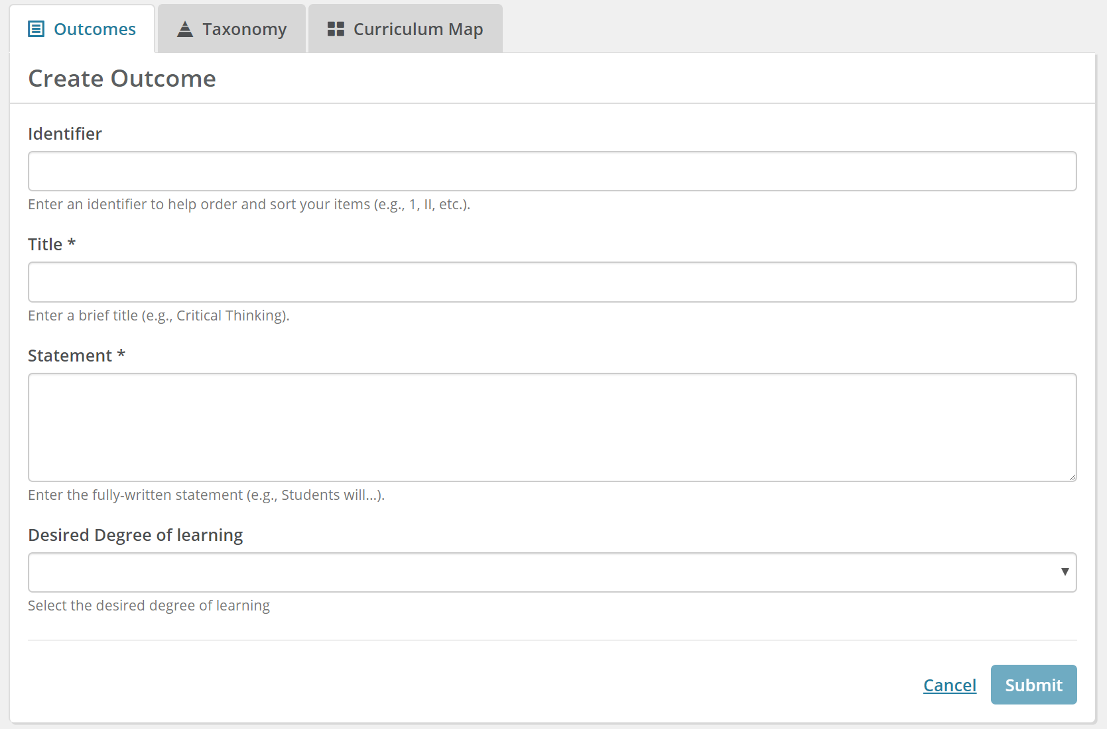

Assessment Template:
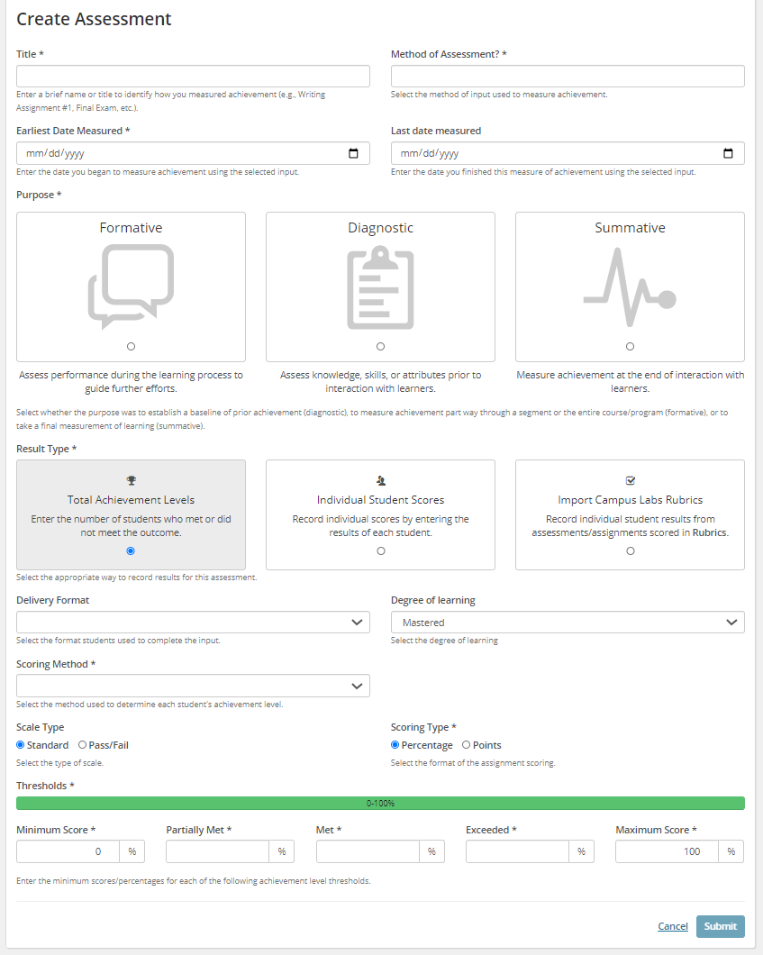

Result Template (and methods for data entry):
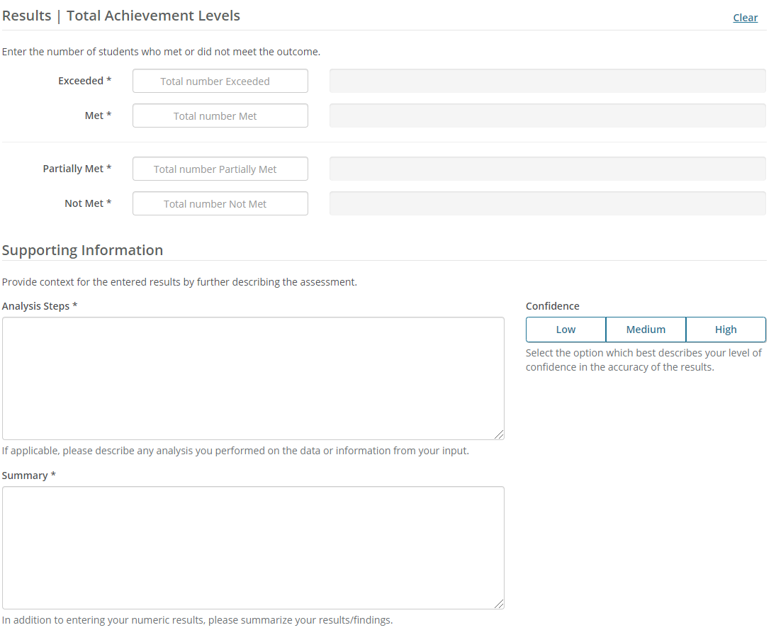

Your Outcomes Framework
Where are outcomes measured/what types of outcomes do you currently have in place at your institution (e.g. General Education Outcomes, Institutional Outcomes, Program Outcomes, Course Outcomes, etc.)?

Thinking of the types of outcomes you provided above- what types of outcomes contribute to larger overarching outcome initiatives (e.g. General Education Outcomes are fulfilled by a specific set of Gen Ed. courses, Program Outcomes are and created based on Institutional Outcomes, etc.)?

Thinking through how outcomes are currently aligned at your campus please map out an example. Please see our example below.

Your Outcomes Framework Working Area

Outcomes Implementation Preparation Action Steps
- Identify Data Manager​ (pg. 4-7)
- Identify Primary Contacts (pg. 4-7)
- Identify Site Administrators (pg. 4-7)
- Identify Champions​ (pg. 4-7)
- Confirm files you intend to use based on reporting goals​ (pg. 8-9)
- Confirm timeline for completing core data (pg. 10)
  - Discuss and prepare an organizational chart (units) for the core data process
  - Coordinate timelines on Campus between Data Manager and Primary Contact(s)/Site Administrator(s)
- Confirm results scale (pg. 11-12)
- Select default Bloom's Taxonomy Version (pg. 13)
- Confirm scoring options​
  - Individual scoring enabled​
  - Rubrics (relevant to campuses with CL Baseline)​
    - LMS integration with Rubrics: Contact consultant to work through option to enable Rubrics integration with your LMS
- Customize templates (pg 14-15)
  - Outcome
    - Edit field language​
    - Edit Instructions ​
    - Determine which fields are required vs. optional​
  - Assessment ​
    - Edit field language​
    - Edit Instructions ​
    - Determine which fields are required vs. optional​
  - Results ​
    - Edit field language​
    - Edit Instructions ​
    - Determine which fields are required vs. optional
- Outline list of all types of outcomes you currently have in place on campus (pg. 17-18)
- Outline outcomes alignment (pg. 17-18)

