Preparing to Onboard Course Evaluations

Contents
Onboarding Timeline 2
Role Descriptions and Worksheet 3
Role Worksheet 4
Onboarding Involvement Levels 4
Data Governance Team 4
Technical Roles 5
Data Manager 5
Authentication Coordinator 6
LMS Administrator 6
Course Evaluations Manager 8
Senior Sponsor(s)/Product Champion(s) 9
Goal Setting 10
Pre-Kickoff Call Questions 10

Onboarding Timeline
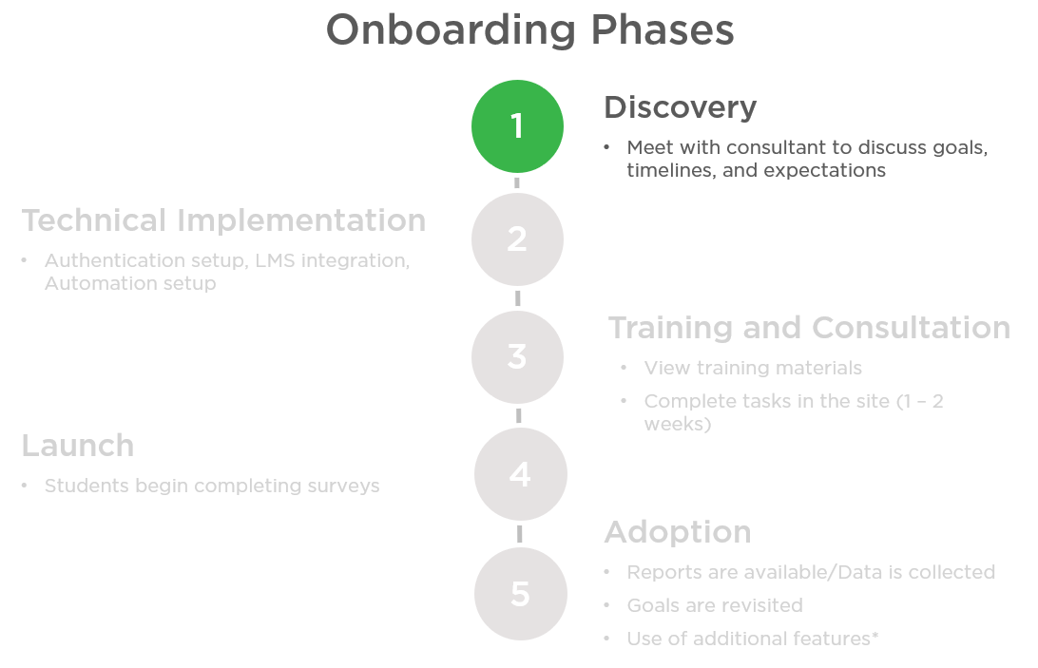

Role Descriptions
Role Worksheet Directions
Who should complete this worksheet?
This worksheet should be completed by the contract signer and/or senior sponsor and supporting team members. This is to be completed by the institution prior to product onboarding. All roles are required unless otherwise noted as optional or relevant to a specific tool not included in your contract.
How will this worksheet be used?
We will use this worksheet to coordinate schedules, meetings, and provide appropriate training and permissions within the toolsets. Please refer to the role dictionary for further descriptions, time commitments/levels of involvement, and examples from other campuses.
How do I complete this worksheet?
Review all potential roles and complete all those that are relevant. If you have questions, please reach out to your onboarding consultant.
What else should I consider?
- Roles are not exclusive
  - An individual may fill multiple roles based on the goals and workflow of your institution and a role may be filled by multiple people. The individual(s) will be responsible for all actions and time commitments in each role. As decisions are made regarding the coordination, timeline, and roles of campus members, consideration of these
  - factors will be essential to a successful onboarding.
- This worksheet should continue to be a reference for your campus and updates should be communicated to Campus Labs as necessary based on role changes.

Role Worksheet
The role worksheet is to be completed by the institution before the kickoff call. All roles are required unless otherwise noted as optional.

Onboarding Involvement Levels

 | High | Medium | Low | N/A
The identified individual should be prepared to: | Dedicate at least 3 hours a week to training or scheduled calls and action items associated with onboarding. | Dedicate around 1-1.5 hour a week to calls and action items. | Updated on progress and may be included in conversations weekly. May be assigned responsibility for an action item if appropriate. | Not involved at this level of onboarding

Data Governance Team
Role | Campus Contact  Name & Title | Campus Contact  Phone & Email
Contract Owner
Individual(s) responsible for decisions regarding changes or continuation of the partnership.
Procurement/Operations specialist
Responsible for receiving the invoice and processing your annual payment associated with this contract.
Senior-level Project Owner
Cabinet level team members accountable for bringing this tool to campus, visioning the strategic use of the toolsets, and the success of the Campus Labs partnership. There should be multiple identified, with at least one per each campus priority.
Project Coordinator
Some campuses find it helpful to have a point person to oversee the implementation project details.

Technical Roles

Data Manager
What are the responsibilities of a Data Manager?
The data manager will be responsibility for creating and managing the updates of the import data files. May be responsible for setting up the automated import process OR manually importing the import files and researching data issues

On other Campuses, who has been a Data Manager?
Data Managers have held positions such as Chief Information Officer, SIS Administrator or have been a member of the IT staff (a programmer, for instance).

What is the level of involvement and time commitment of a Data Manager in onboarding and implementation?

Onboarding | Technical Implementation | Implementation Training | Launch | On-going support
Medium | High | Low | Low | Low

They may be responsible for instituting the proper exchange system, maintaining ongoing communication with our Technical Implementation Specialists to work through the process, and carrying out the actual construction of the import files.

What is the level of involvement and time commitment of a Data Manager after launch?
The Data Manager will maintain the import process and update files when necessary.

Authentication Coordinator
What are the responsibilities of an Authentication Coordinator?
Campus Labs connects to campus authentication systems to identify and credential users. The centerpiece of each method is a secure transmission of a unique identifier for a user upon a successful granting of credentials. The Authentication Coordinator will be responsible for filling out the authentication worksheet and working with Campus Labs Technical Specialists to complete authentication set up and procedures. They will also need to communicate the designated external identifier to all Data Managers and Course Evaluations Contacts for the life of the Course Evaluations product.

On other Campuses, who has been an Authentication Coordinator?
Authentication Coordinators have held positions such as Chief Information Officer and SIS Administrator; they have also been members of the IT staff who can facilitate authentication set up.

What is the level of involvement and time commitment of an Authentication Coordinator in onboarding and implementation?
Onboarding | Technical Implementation | Implementation Training | Launch | On-going support
Medium | Medium | Low | Low | Low

Authentication will be one of the first steps completed during on-boarding. The Authentication Coordinator will participate in conversations and attend meetings about selecting the appropriate authentication method and external identifier. They will also be responsible to make sure all new users are added with their external identifier. This could require communication with Data Managers and Primary Course Evaluations Contacts.

What is the level of involvement and time commitment of an Authentication Coordinator after launch?
The Authentication Coordinator will maintain the Authentication process and make sure any new data managers are aware of authentication procedures. They may occasionally be called upon should changes need to be made to the campus’ authentication method or configuration.

LMS Administrator
What are the responsibilities of an LMS Administrator?
Campus Labs connects to campus learning management systems to help maximize Course Evaluations exposure to students and faculty ,as well as, to increase student response rates. The LMS Administrator will be responsible for working with Campus Labs Technical Specialists to complete the LMS LTI set up. They will also need to test the integration and communicate changes to the Course Evaluations Contacts for the life of Course Evaluations product.
On other Campuses, who has been an LMS Administrator?
LMS Administrators have held positions such as Chief Information Officer and LMS Administrator; they have also been members of the IT staff who can facilitate LMS LTI set up.
What is the level of involvement and time commitment of the LMS Administrator in onboarding and implementation?
LMS/LTI setup can be one of the first steps completed during on-boarding or it can be completed at any time. The LMS Administrator will participate in conversations and attend meetings about setting up the integration and explaining how the integration works. They will also be responsible to communicate with the Primary Course Evaluations Contacts.

Onboarding | Technical Implementation | Implementation Training | Launch | On-going support
Low | High | N/A | N/A | Low

What is the level of involvement and time commitment of the LMS Administrator after launch?
The LMS Administrator will maintain the LMS integration process and make sure any new Course Evaluations managers are aware of integration. They may occasionally be called upon should changes need to be made to the campus’ LMS configuration.

Role | Campus Contact  Name & Title | Campus Contact  Phone & Email
Data Manager(s)
Responsible for creating and managing the updates of the import data files. May be responsible for setting up the automated import process OR manually importing the import files and researching data issues.
Authentication Coordinator
Configure authentication to set up the external authentication method.
LMS administrator (OPTIONAL)
Access to install modules within your LMS.

Course Evaluations Manager
What are the responsibilities of a Course Evaluations Manager?
This role is responsible for the development and oversight of Course Evaluations. The manager will be the main point of contact during implementation, rollout, and continued development of Course Evaluations. They will be responsible for:
- Onboarding the Course Evaluations platform with an understanding of its relationship to the campus’ course evaluation strategy.
- Maintenance of the Course Evaluations platform, including contributing to the initial site construction, controlling settings, determining users and permissions, and understanding the detailed functionality of the tool.
- Communicating choices concerning the Course Evaluations platform to relevant stakeholders on campus.

We recommend that there are between 1-2 managers for Course Evaluations. Sometimes, a campus may distribute these duties over multiple people. For example, a subject-matter expert in Institutional Effectiveness or Academic Affairs and an administrative assistant for support and maintenance.

The Manager will also be informed about all product updates, additional features, and integrations, and have direct connection to the Course Evaluations consultant. For questions that arise regarding the contract, site configuration, or changes to the community, the Project Manager will always serve as the primary point of contact.

On other Campuses, who has been a Course Evaluations Primary Contact?
Managers have held such titles as Associate Provost, Registrar, Learning Assessment Director, Director of Institutional Research, Associate Dean, Administrative Assistant.

What is the level of involvement and time commitment of a Course Evaluations Manager during onboarding?
Onboarding | Technical Implementation | Implementation Training | Launch | Ongoing Support
High | High | High | High | Medium

Course Evaluations Managers may be involved in the import preparation during onboarding and technical implementation. They will attend a three-part onboarding training series introducing settings and functionality of the tool.

What is the level of involvement and time commitment of a Course Evaluations Manager after launch?
The Manager will be a contact point on campus for users as well as a contact point for Campus Labs regarding check-ins, product updates, and product communications.

Product | Campus Contact  Name & Title | Campus Contact  Phone & Email
Course Evaluations Manager

Senior Sponsor(s)/Product Champion(s)
What are the responsibilities of a Senior Sponsor/Product Champion?
A Campus Labs Senior Sponsor/Product Champion is a campus resource who can act in an influential manner on campus. A Senior Sponsor will act as a liaison between the campus audience and the Campus Labs products. The Senior Sponsor is someone who supports the mission of the campus as well as the solutions proposed in the Campus Labs platforms and is willing to be an advocate on campus. They are a voice from within the campus, an influencer for the adopted solutions, a coach to other users, and a person who will help with successful adoption on campus. The specific responsibilities will vary based on the product, campus environment, and the goals being pursued, but Senior Sponsors are generally involved in the launch and adoption of the product on campus.

On other Campuses, who has been a Senior Sponsor?
Senior Sponsors are part of the targeted user base on campus. They have held a variety of positions dependent on the platform and targeted audience.

What is the level of involvement and time commitment of a Course Evaluations Senior Sponsor during onboarding?
Onboarding | Technical Implementation | Implementation Training | Launch | On Going Support
Low | Low | Low | High | Medium

What is the level of involvement and time commitment of a Senior Sponsor after launch?
A Senior Sponsor will work to know the purpose of the platform and how to showcase its usefulness to the broader audience. A Senior Sponsor will work to build support and engagement with the campus goals among the target audience.

Product | Campus Contact  Name & Title | Campus Contact  Phone & Email
Course Evaluations Senior Sponsor

Goal Setting
What are your campus’ goals for using the Course Evaluations site? How do you hope to leverage your evaluation data?
GOAL 1:

GOAL 2:

GOAL 3:

Pre-Kickoff Call Questions
On behalf of everyone at Campus Labs, we would like to welcome you to our member campus community. We are excited to be working with you though this onboarding journey!
The purpose of these questions is help you collect the needed information for Course Evaluations onboarding. Please answer these questions and return this information to us.
Once we receive the worksheet, we can schedule the Onboarding Kick-Off Call, which is the next step in the onboarding process.

- Which department will be managing the course evaluation process?

- Can you describe your current instrument/s? Do you use a common instrument, or are there multiple instruments used on campus?

- Do you desire any consultation on your instrument?

- Who can/should see reporting on your campus (instructors, department chair, deans, provost/president)?

- How do you use/leverage your evaluations data currently?

- Are all course sections evaluated for all instructors? If not, what determines whether a section is evaluated or not?

- Are all sections evaluated at the same time at the end of the semester or do you have intercessions that run evaluations at different times?

- What are your current response rates for the institution?

- What is your response rate goal for onboarding?

- How are you planning to communicate this new platform to students and faculty?

- What is your estimated launch timeline (when do evaluations need to launch…and when will reports need to be released post-evaluation)?

- What Learning Management System (LMS) do you currently utilize?

- What authentication method do you currently utilize? (Shibboleth, CAS, ADFS)?

